Smartphone Apps as GPS to utilize GPX files for Club rides

In Route App
- Download is free, allows routes with 8 or fewer waypoints
- Many routes have many more than 8 waypoints
- Premium subscription allows 150 wwaypoints per route and has turn by turn audio instructions
  - $5.00 per month
  - $40.00 per year
- Jim Craig uses this app
- Jim’s instructions follow

Open Safari on your iPhone and open the calendar on the shadowriders-stl.com website (click on the three little lines under the Shadow Riders logo and select calendar).
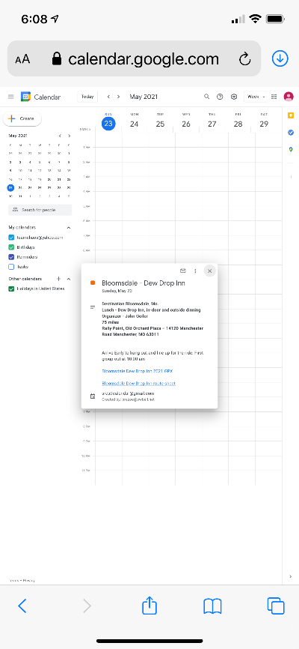
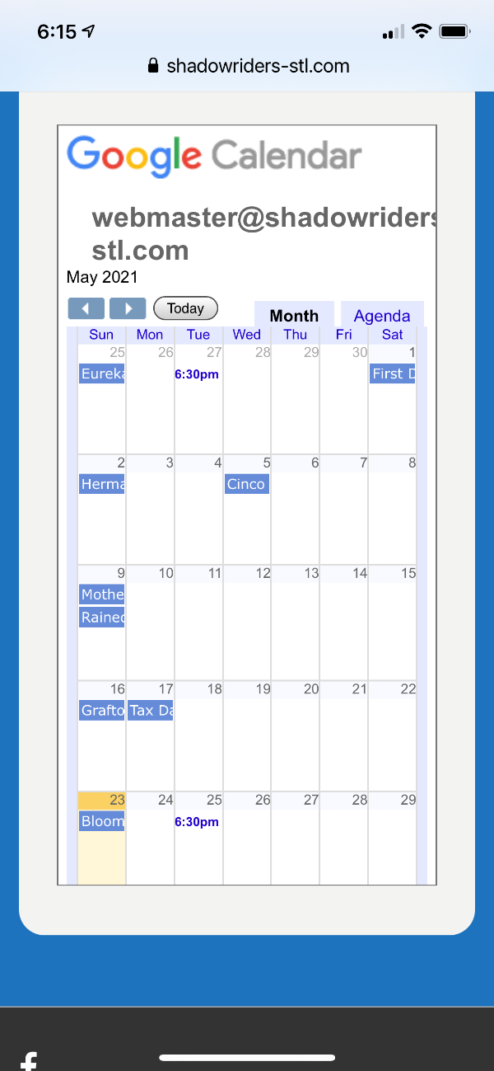
Click on the date on the calendar for the ride.
This will open up the ride information in Google calendar.
Click the link to download the GPX file. In this example Bloomsdale Dew Drop Inn 2021 GPX
This will open the link and present a red download button (see next screen shot)

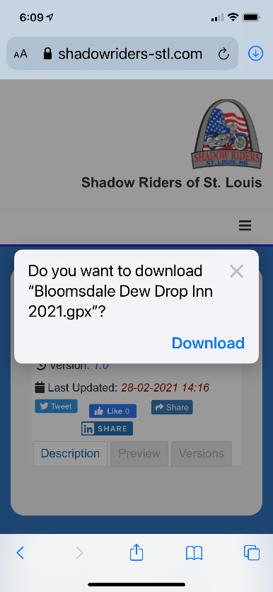
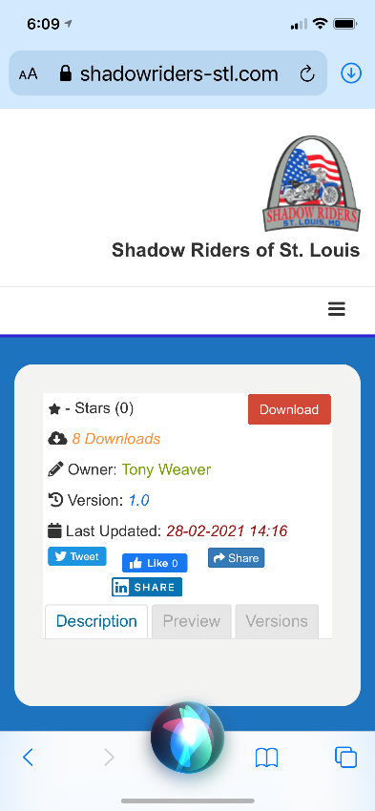

Click the download buton.
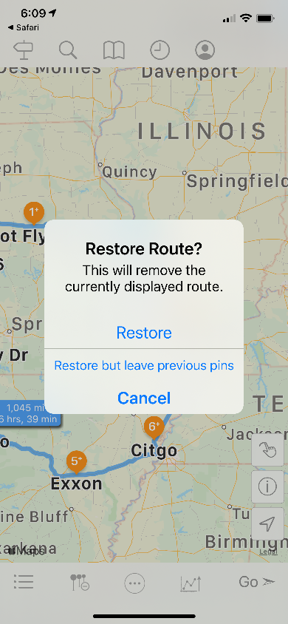
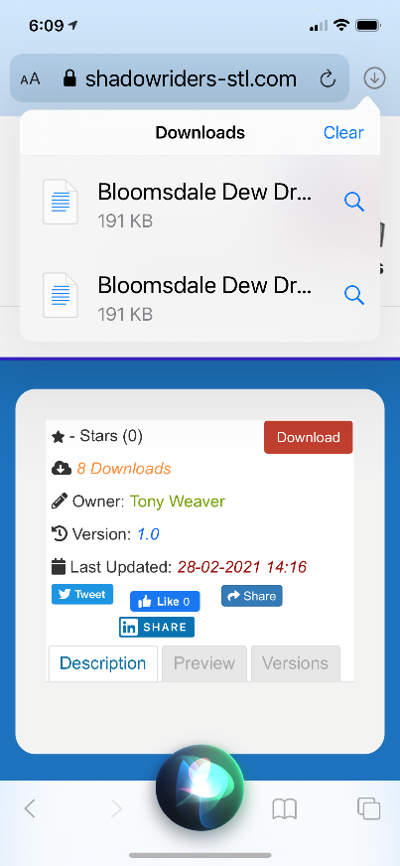
Select Download.
Tap the down arrow in the circle at the top right hand corner of the screen and then click on the GPX file that was downloaded.

This will open the GPX file in the InRoute app.
Select Restore in the InRoute app.

When you’re ready to ride, click Go in the lower right-hand corner of the app.
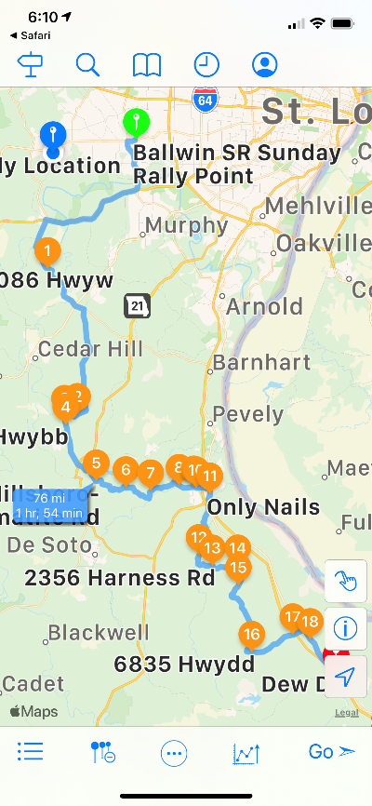

Scenic App
- Free download includes no maps, 20 credits to start account
- Uses credit system to purchase maps and import routes (1 credit per route imported)
- Credits approx. $0.50 per, price drops as larger blocks are credits are purchased at one time
- US map 75 credits -$33.00
- Canada map 50 credits - $21.00
- Cost to purchase individual states varies from 3 to 8 credits
- Premium $22.50 /year or $80.00/lifetime, still requires the purchase of maps
- Premium has turn by turn instructions
- YouTube tutorials are online

